**TASK 3 :**

**3(A):** **To implement of A * Algorithm to find the optimal path using Jupiter notebook.**

**Program :**

def aStarAlgo(start_node, stop_node):

open_set = set([start_node])

closed_set = set()

g = {} # store distance from starting node

parents = {}

g[start_node] = 0

parents[start_node] = start_node

while len(open_set) > 0:

n = None

# node with the lowest f() is found

for v in open_set:

if n is None or g[v] + heuristic(v) < g[n] + heuristic(n):

n = v

if n == stop_node or n is None or Graph_nodes[n] is None:

break

else:

for m, weight in get_neighbors(n):

if m not in open_set and m not in closed_set:

open_set.add(m)

parents[m] = n

g[m] = g[n] + weight

else:

if g[m] > g[n] + weight:

g[m] = g[n] + weight

parents[m] = n

if m in closed_set:

closed_set.remove(m)

open_set.add(m)

open_set.remove(n)

closed_set.add(n)

if n is None:

print('Path does not exist!')

return None

if n == stop_node:

path = []

while parents[n] != n:

path.append(n)

n = parents[n]

path.append(start_node)

path.reverse()

print('Path found:', path)

return path

print('Path does not exist!')

return None

def get_neighbors(v):

if v in Graph_nodes:

return Graph_nodes[v]

else:

return None

def heuristic(n):

h_dist = {

'A': 11,

'B': 6,

'C': 5,

'D': 7,

'E': 3,

'F': 6,

'G': 5,

'H': 3,

'I': 1,

'J': 0

}

return h_dist[n]

Graph_nodes = {

'A': [('B', 6), ('F', 3)],

'B': [('A', 6), ('C', 3), ('D', 2)],

'C': [('B', 3), ('D', 1), ('E', 5)],

'D': [('B', 2), ('C', 1), ('E', 8)],

'E': [('C', 5), ('D', 8), ('I', 5), ('J', 5)],

'F': [('A', 3), ('G', 1), ('H', 7)],

'G': [('F', 1), ('I', 3)],

'H': [('F', 7), ('I', 2)],

'I': [('E', 5), ('G', 3), ('H', 2), ('J', 3)],

}

print("Following is the A* Algorithm:")

aStarAlgo('A', 'J')

**Output :**

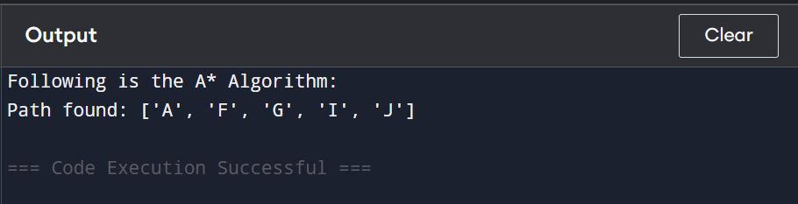

**3(B) : : To implement the simplified A*Algorithm using Jupiter notebook.**

**Program :**

def aStarAlgo(start_node, stop_node):

open_set = set([start_node])

closed_set = set()

g = {} # store distance from starting node

parents = {} # parents contain an adjacency map of all nodes

g[start_node] = 0

parents[start_node] = start_node

while len(open_set) > 0:

n = None

for v in open_set:

if n is None or g[v] + heuristic(v) < g[n] + heuristic(n):

n = v

if n == stop_node or n is None or n not in Graph_nodes:

break

else:

for m, weight in get_neighbors(n):

if m not in open_set and m not in closed_set:

open_set.add(m)

parents[m] = n

g[m] = g[n] + weight

else:

if g[m] > g[n] + weight:

g[m] = g[n] + weight

parents[m] = n

if m in closed_set:

closed_set.remove(m)

open_set.add(m)

open_set.remove(n)

closed_set.add(n)

if n is None:

print('Path does not exist!')

return None

if n == stop_node:

path = []

while parents[n] != n:

path.append(n)

n = parents[n]

path.append(start_node)

path.reverse()

print('Path found:', path)

return path

print('Path does not exist!')

return None

def get_neighbors(v):

if v in Graph_nodes:

return Graph_nodes[v]

else:

return None

def heuristic(n):

h_dist = {

'A': 11,

'B': 6,

'C': 99,

'D': 1,

'E': 7,

'G': 0

}

return h_dist[n]

Graph_nodes = {

'A': [('B', 2), ('E', 3)],

'B': [('A', 2), ('C', 1), ('G', 9)],

'C': [('B', 1)],

'D': [('E', 6), ('G', 1)],

'E': [('A', 3), ('D', 6)],

'G': [('B', 9), ('D', 1)]

}

print("Following is the A* Algorithm:")

aStarAlgo('A', 'G')

**Output :**

